**2o21 Prayer List**



**February 20, 2021 – February 28, 2021**

**First Sunday of Lent**

**Saturday: Feb. 20, 2021** Genesis 9:8-15;

1 Peter 3:18-22; Mark 1:12-15

4:00 pm St. Mary: **†** Wayne & **†** Vivien Farrar & Family,

**†** Winston Hammond & **†** Danielle Carpenter

5:30 pm St. Benedict: St. Benedict’s Families & **†** Raymond Grenier

**Sunday: Feb. 21, 2021** Genesis 9:8-15;

1 Peter 3:18-22; Mark 1:12-15

8:30 am St. Edward: **†** Marita Lalime & **†** David Lalime

9:30 am St. Mary: **†** Allen Raboin & **†** Souls in Purgatory

**Please call the parish office at**

**(802) 334-5066 if you would like to add a name to the**

**Prayer List.**

10:30 am St. James: **†** Jeremy Maxwell & **†** Esperanza Robles,

Members of the Castonguay Family &

**†** Deceased Members of the Goulet Family

11:00 am St. Mary: **†** Sr. Rita, **†** Sr. Rose & **†** Sr. Angelina

**Monday: Feb. 22, 2021** 1 Peter 5:1-14, 25; Matthew 16:13-19

**Chair of St. Peter the Apostle**

Tanner Blais

Lorraine Blake

Gabrielle Bolton

Yolande Brasseur

Yolande Bronson

William Brooks

Anna, Restituta, Andrew,

Mary & Josephine Buono

Sara Chaput

Kevin Charboneau

Lyse Comeau

Stephen Comeau

Andrew Delabruere

Brenda Deslandes

Marcel Deslandes

Paul Diette

Jean Diette

Fr. Michael Dobbins

Maci Fournier

Pat Gray

Kathy Huffman

Carol Janson

Bernadette Kelley

Jenny Kirsch

Rita Lantagne

Nancy Lawson

Sue Leavitt

Robbie Lynn LeBlanc

John & Donna Major

Thomas McLellan

Fr. Curtis Miller

Francois Morin

Joshua Noble

Michael Poginy

Roger Raboin

John Ricard

Robert Rivard

Fr. Shawn Roberson

Bernadette Stanis

Regina Switser

Neila Venne & Siblings

Ethan Ward

Cecile Wheeler

Yvonne Wood

Sandy Worth

Richard Wyman

9:00 am St. Mary: Intentions of Deacon Ward & Kathy Nolan

4:00 pm St. Mary: Healing of Vocationist Fathers and Sisters

suffering from the Coronavirus in Italy

**Tuesday: Feb. 23, 2021** Isaiah 55:10-11; Matthew 6:7-15

**St. Polycarp: Bishop & Martyr**

9:00 am St. Mary: Intentions of the Parish Staff & Families

4:00 pm St. Mary: Intentions of Pope Francis

**Wednesday: Feb. 24, 2021** Jonah 3:1-10; Luke 11:29-32

9:00 am St. Mary: **†** Anna Sanville

12:00 pm St. Mary: Mater Dei Parish Families

4:00 pm St. Mary: Intentions of Bishop Coyne

**Thursday: Feb. 25, 2021** Esther C:12, 14-16, 23-25;

Matthew 7:7-12:

9:00 am St. Mary: **†** David Foy

4:00 pm St. Mary: **†** Deceased Members of Gosselin

& Fugere Families

**Friday: Feb. 26, 2021** Ezekiel 18:21-28; Matthew 5:20-26

9:00 am St. Mary: **†** Judy Foy

10:30 am St. James: Stations of the Cross

11:00 am St James: **†** 2021 Covid 19 Victims

4:00 pm St. Mary: **†** All Souls

4:30 pm St. Mary: Stations of the Cross

5:30 pm St. Edward: For a Faith-Filled & Fruitful Lent

6:00 pm St. Edward: Stations of the Cross

**Saturday: Feb. 27, 2021**  Deuteronomy 26:16-19;

 





Matthew 5:43-48

**Prayer for the Sick**

Father God, we lift up those who are facing illness today.

We ask that you bring healing, comfort, and peace to their bodies.

Calm their fears and let them experience the healing power of Your love.

In Jesus’ name we pray. Amen

**St. Gregory of Narek: Abbot and Doctor of the Church**

9:00 am St. Mary:  Victoria Martin

**Second Sunday of Lent**

**Saturday: Feb. 27, 2021** Genesis 22:1-2, 9a, 10-13, 15-18,

Romans 8:31b-34; Mark 9:2-10

4:00 pm St. Mary: **†** Deceased Members of Ephrem Fournier

Family

5:30 pm St. Benedict: **†** Deceased Members of St. Benedict’s

**Sunday: Feb. 28, 2021** Genesis 22:1-2. 9a, 10-13, 15-18

Romans 8:31b-34, Mark 9:2-10

8:30 am St. Edward: **†** Bernadette Nadeau & **†** Rene &

**†** John Gaudreau

9:30 am St. Mary: **†** Sean Joyal & **†** Michael Gonyaw

10:30 am St. James: **†** Jeremy Maxwell & **†** Esperanza Robles,

**†** Joseph Fournier & Families of St. Bernard’s in Norton

11:00 am St. Mary:Healing of those on our Parish Prayer List

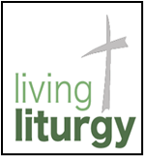 Repent and Believe in the Gospel

The readings for the First Sunday of Lent are short but thought provoking.

In the first reading from Genesis, God establishes a covenant with Noah

and his family and every living creature, promising that He would not

destroy mortal beings by flood waters. As a sign of His covenant, God

would send a “bow” - a rainbow - into the clouds to remind Him of His promise or covenant to Noah and his descendants. What is this covenant really? Let us consider that this covenant is really *salvation*, just as God’s first covenant with the Israelites was for their salvation.

In the second reading, St. Peter tells us of Christ’s great suffering for the sins of the unrighteous - mankind. You might note that Noah and his family were saved by *water.* We can think of it as the baptism which saves us today. We await the refreshing waters at Easter for our rebirth with Christ, the baptism that is the great sign of God’s everlasting love for us.

Today’s Gospel describes how Jesus, after His baptism, went into the desert for 40 days and was tempted by Satan. We must remember that Jesus was also human and tempted by the evil one just as we are. The wild beasts - evil ones - would be incredibly happy if they could make Jesus fall to their false promises. But Jesus was “filled with the Holy Spirit” - the angels, the servants of God, helped the human Jesus with his struggles to resist their temptations. Jesus returned from the desert stronger, knowing that He had to proclaim the “Kingdom of God. Re*pent and believe in the Gospel.”*

Today, we should remember that we are not alone either. We also have angels ministering to our needs, empowering us, and comforting us anytime we need them. The Lord is always present to us; however, *we must remember that it is up to us to give ourselves Him. His door is ALWAYS OPEN AND WAITING FOR YOU.*

This is the beginning of Lent, a time not “to just give up something for Lent”, *but a time to be awakened spiritually and give up those things that are not serving our relationship with the Lord.* How can we awaken ourselves spiritually? Attend daily Mass, read the Holy Scriptures every day, and go to Confession. Let us become more like Jesus, our Master, and submit ourselves to the discipline of His Words and His saving power. Amen.

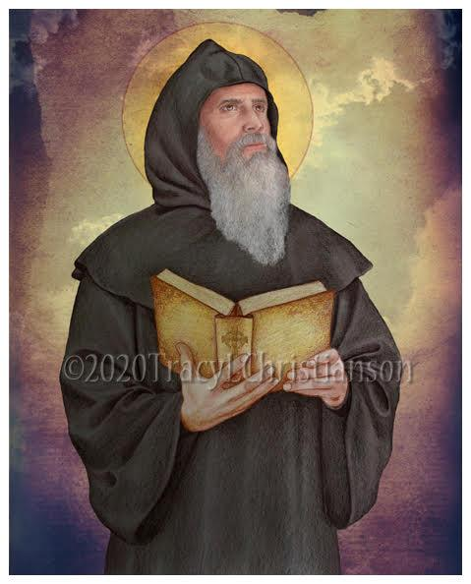

**St. Gregory of Narek**

In a decree issued on February 2, 2021, Pope Francis set aside February 27th as the feast day of St. Gregory of Narek, an Abbot and Doctor of the Church.

St. Gregory of Narek is widely revered as one of the greatest figures of medieval Armenian religious thought and literature. Born in the city of Narek, Armenia – which is now Turkey - in about 950 A.D., St. Gregory became a priest at the age of 25 and dedicated himself to God. He lived most of his life at the monastery of Narek where he taught at the monastic school.

St. Gregory began his writings with a commentary on the “Song of Songs” which became famous for its clarity of theological thought and language. His masterpiece is considered to be his Book of Lamentations. Also known as Narek, it is comprised of 95 prayers, each of which is titled “Conversation with God from the depth of the heart”. A central theme of the prayers is man’s separation from God and his quest to reunite with him. St. Gregory called his book an “encyclopedia of prayer for all nations” and hoped that it would serve as a guide to prayer for people all over the world. The book was published in 1673 and has been translated into over 30 languages.

Many of St. Gregory’s prayers are included in the Divine Liturgy celebrated

each Sunday in Armenian Churches around the world.

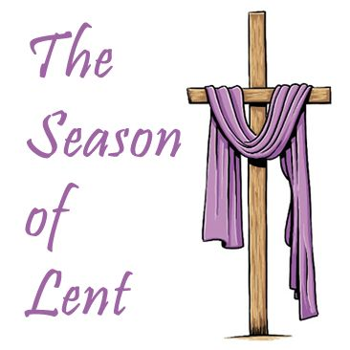 **Indulgences and the Temporal Punishment for Sins**:

*You Have to Fix the Window*

Billy Johnson and his friends were allowed to play baseball in front of Billy’s house, but

only on one condition. They must use a soft tennis ball instead of a rock hard “real”

baseball. This was to prevent breaking the neighbors’ windows. One fine summer

afternoon they realized that they had no tennis ball, only a forbidden baseball. Their

ringleader, Joey, quickly called for a vote: “We either play here, where we have access to

all the snacks and sodas in the kitchen, or we hoof halfway across town to the park, which we know will be jam packed.”

Only Billy voted to go to the park. Truth be known, he was happy with the vote: he liked being the guy who could make the fun happen for once in his life. The inevitable happened in the third inning. Billy’s best friend, Sal, drove the first pitch right across the street and through the center of the Johnson’s living room window. The friends scattered, leaving Billy alone to face his father.

Billy’s dad was surprisingly calm about the whole thing. He sent Billy to his room while he called Mr. Johnson to work things out. He then walked Billy across the street and waited at the curb while his twelve-year-old son went to the door to apologize to the Johnsons.

The next day, two men from the glass company came to Billy’s house. Billy’s dad took Billy with him to the Johnsons’ to watch the men install the new window. Billy’s dad wrote a check and gave it to the workers. They shook hands all around – including a surprised Billy – and then Billy and his dad went home.

When they got back home, Billy’s dad asked him if he understood what had just happened. Billy said he was pretty sure he did. “It’s not enough just to apologize. I have to fix the window to make everything right. Is that it, Papa?”

“That is exactly right, son.” “But Papa,” Billy said, “I didn’t fix the window. You paid to have it fixed, but you didn’t break it.” “Yes? So?” “That window looked pretty expensive. How am I ever going to repay you for it?” “You only have to pay what you can, Billy. How about if you mow the lawn every Saturday until the end of summer vacation?” Billy was thrilled with this suggestion. (He loved pushing the big, loud power mower around the yard.)

“That’s all, Papa?” Billy asked, grinning from ear to ear. “That’s all, son. And once the summer ends, we never need to discuss any of this again – it never happened. Okay?” “Okay Papa.”

* * *

We all leave broken windows in our wakes as we navigate through our lives. All of this adds up. We rarely consider what happens to the people we have hurt along the way. Sure, we went to confession and did our penance, and received absolution. But what about all those broken windows? Can I get into heaven if I still don’t care about the people I have hurt over the years? How will that part of me that didn’t care that I was hurting people get fixed?

We have two choices: Purgatory and Indulgences.

In purgatory God will burn the affection for sin out of us all in one horrifying operation. An indulgence, on the other hand, wipes away – partially or completely – this need for healing, which we call the “temporal punishment for sin.” Note carefully: An indulgence does not absolve us of our sins – it merely shortens the time we need to spend in God’s blast furnace having the desire for sin burned out of us.

An indulgence may be earned in many ways, but they all boil down working for the salvation of the world in one of two ways: by working very hard within a structure provided by the Church, first, to sanctify myself, and secondly to sanctify others. Both of these happen mostly through prayer. So, either we work off our temporal punishment in this life by earning indulgences or God burns it out of us via His blast furnace.

Our choice.